Year Group: 1 | Autumn 1 | Autumn 2 | Spring 1 | Spring 2 | Summer 1 | Summer 2
Project title | Once Upon a Time | The Land of Ice and Snow | Toys | Fossil Hunters | How Does Your Garden Grow? | Let’s Explore!
Driver | Science/DT | Science/  Geography | History/D.T | History/Art | Science / DT | Geography/Art
Key question | What makes a great story? | Are Polar Bears white? | Do we play with the same toys as our grandparents? | What have we discovered? | What shall we grow today? | Why come to Oliver’s Battery?
Hook | Letter from ‘The Three Little Pigs’ asking for the children help to build a new home and save them from the wolf!. | Artic/ Antarctic expedition/role play | Grandparent talk about toys | Archaeology Dig  Science Week Trip  (Planetarium Winchester) | Hillier Garden’s  visit | Local area trip – Oliver’s Battery shop/park
Outcome | Create a moving ‘Once Upon A Time’ book | Exhibition to year R children to show their project about Antarctica / Artic | Create a class Toy Museum. | Create a Fact File about dinosaurs. | Cook pizza using the vegetables that we have grown. | Creating maps and plans of the school
Enrichment opportunities | Story teller visit | Drama role play Antarctica expedition | History Artefacts box about toys from the past (Hampshire Resource Centre) | History Artefacts box about Mary Anning & dinosaurs (Hampshire Resource Centre) | Trip to Hillier Garden’s. | Explore school grounds
Science:  Longitudinal Study- How do plants and animals survive the changing seasons? Do the seasons affect habitats? | Describing Materials unit 1  Distinguish between an object and the material from which it is made.  Identify and name a variety of everyday materials, including wood, plastic, glass, metal, water, and rock. | Animals – unit 1  Identify and name a variety of common animals including fish, amphibians, reptiles, birds and mammals.  Identify and name a variety of common animals that are carnivores, herbivores and omnivores. | Materials unit 2  Describe the simple physical properties of a variety of everyday materials.  Compare and group together a variety of everyday materials on the basis of their simple physical properties. | Seasons unit  Observe changes across the 4 seasons.  Observe and describe weather associated with the seasons and how day length varies. | Plants unit  Identify and name a variety of common and wild and garden plants, including deciduous and evergreen trees.  Identify and describe the basic structure of a variety of common flowering plants, including trees. | Science  Animal – including humans  Describe and compare the structure of a variety of common animals.  Identify, name, draw and label the basic parts of the human body and say which part of the body is associated with each sense.
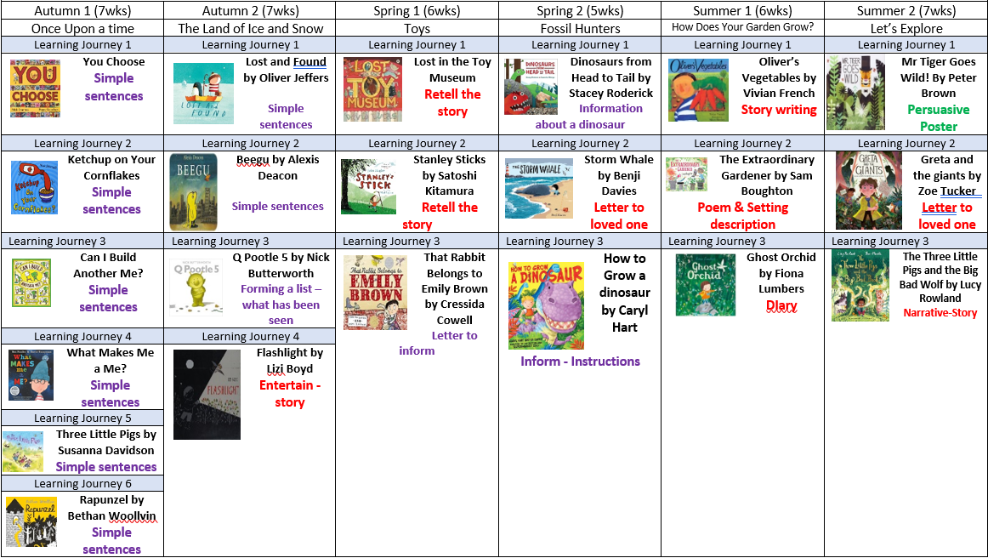
History |  |  | How have people’s lives changed in living memory? Toys - Recount changes that have occurred in their own lives.  Use words and phrases such as: a long time ago, recently, when my parents/carers were children, years, decades and centuries to describe the passing of time.  Music: Explore ways that music has changed in the last 60 years.  Food: Look at ways that food has changed in last 60 years.  Look at most popular foods from other continents.  Transport: Discover how improved transport has made the world more connected. | Mary Anning  To know when Mary lived and the main events in her life. To know why Mary was not celebrated as widely as now during her lifetime. To mention some names used for curiosities e..g dragons, crocodiles.  Ask questions such as: What was it like for people? What happened? How long ago?  Recognise that there are reasons why people in the past acted as they did.  Label time lines with words or phrases linked to events in Mary’s life
Geography |  | Cold Places- What is it like in the North and South Poles?  What is it like at the North and South Poles? I can locate the North and South Polar Regions and describe some of their icy regions.  I can talk about the Artic circle and describe the seasonal changes.  I can describe some of the wildlife found in the artic regions and how they are affected by the seasons. I can explain how people have adapted to living in the harsh conditions. |  |  |  | Where do we go to school?  Explore our school and different places and buildings within it.  I can find the features of my school ground on aerial photo’s and maps. Find out about the people who work at the school and interview them to find out more about their jobs.  Using locational language to describe places that they have seen. I can use geographical vocabulary to describe the seasonal signs in the school grounds.
Art | Access Art:  Spiral  Disciplines:  Drawing, Collage, Sketchbooks  Medium:  Graphite stick or soft B pencil, Handwriting Pen, Pastels & Chalk, Paper, (Sketchbook Making Task: Paper, string, elastic bands, glue)  Artists: Molly Haslund | Access Art:  Exploring Watercolours  Disciplines:  Painting (Watercolour)  Medium:  Watercolour  Artists:  Paul Klee, Emma Burleigh | Access Art: Drawing exercises | Access Art:  Playful making  Disciplines:  Sculpture, Drawing  Medium:  Construction Materials (card, paper, wood, wire, string, fabric including recycled and found objects)  Artists:  Christo & Jeanne-Claude, Faith Bebbington, Caitlind r.c. Brown & Wayne Garrett | Access Art:  Simple Printmaking  Disciplines: Printmaking, Collage, Drawing  Medium:  Paper, Printing Ink, Plasticine, Printing Foam | Access Art:  Inspired by flora and fauna  Disciplines:  Drawing, Collage, Sketchbooks  Medium:  Handwriting pen, Graphite, Oil pastel, Paper & Collage  Artists: Eric Carle, Joseph Redoute, Jan Van Kessel
DT | Projects on a page: Sliders and levers  Explore different moving cards, pictures and images. Develop skills in making a moving picture using pivots, levels and sliders. |  | Projects on a page: Structures  Explore the local playground and look at joining techniques. Make models of different playground equipment and learn joining skills. Make playground equipment for a toy. |  | Projects on a page: Food  Develop and explore cutting, chopping, grating, peeling and slicing skills. Design and make a fruit salad using techniques learnt.
PE | Gym – Basic Shapes  Children demonstrate the basic shapes and show control.  Children travel with a chosen shape.  Basic ball skills  To explore and have an awareness of space.  To become familiar with balls, large and small - rolling and controlling. | Dance - Autumn  Perform a simple movement pattern and improvise in response to music.  Basic ball skills  To practice a push (chest) pass, focus on body position and technique for receiving the ball and catching. | Gym – Apparatus  To explore apparatus using different shapes, directions, levels and speeds. To be aware of the risks when using and moving around apparatus.  Invasion Games  In this unit children develop basic game-playing skills, in particular throwing and catching. They play games based on net games (like tennis and badminton), and games based on striking and fielding games . | Dance - Dinosaurs  Children learn to copy and repeat movements and perform in a large group. Children learn about timing and synchronization.  Throwing and catching  To throw a ball with one hand (underarm) and two hands (overhead). To aim for a target and throw accurately. | Net/Wall  Children become familiar with a bat and ball. Children will use the bat to roll a ball and hit a ball into a space.  Athletics  Children will develop agility and co-ordination in running, jumping and throwing activities. | OAA  Children will recognise where they are on a plan or diagram of the school hall/playground/field. They will travel successfully to and from objects and locations on the ground.  Striking and fielding  Children will practice the skills of bouncing throwing and catching, using bean bags, small balls. Will learn to hit a ball using a bat to run, to score a point.
RE | Theme/Unit: Harvest  Key concept:  Celebration | Theme/Unit: Journeys End  Key concept: Nativity | Theme/Unit: Creation stories  Key concept: Creation | Theme/Unit: Easter  Key concept: Sad and happy | Theme/Unit:  Passover  Key concept:  Remembering | Theme/Unit: Special places (church)  Key concept: Specialness
PSRE: Jigsaw | Being Me in My World | Celebrating difference | Dreams and goals | Healthy Me | Relationships | Changing Me
Music | Charanga:  Introducing Beat  Settings and sound scrapes.  Take part in singing, accurately following the melody.  Clap rhythms.  Create a mixture of different sounds (long and short, loud and quiet, high and low).  Choose sounds to create an effect. | Charanga:  Adding rhythm and pitch  Take part in singing, accurately following the melody.  Follow instructions on how and when to sing or play an instrument. | Charanga:  Tempo and dynamics  Create a sequence of long and short sounds.  Clap rhythms. Follow instructions on how and when to sing or play an instrument. | Charanga:  Combining pulse, rhythm and pitch  Create a sequence of long and short sounds.  Clap rhythms.  Create a mixture of different sounds (long and short, loud and quiet, high and low).  Choose sounds to create an effect.  Sequence sounds to create an overall effect. | Charanga:  Having fun with improvisation  Take part in singing, accurately following the melody.  Follow instructions on how and when to sing or play an instrument.  Make and control long and short sounds, using voice and instruments. | Charanga:  Explore sound and create a story.  Choose sounds to create an effect.  Sequence sounds to create an overall effect.  Take part in singing, accurately following the melody.  Follow instructions on how and when to sing or play an instrument.
Computing | Computer Systems and networks – Technology around us | Creative media- digital painting | Programming – Moving a robot | Data and Information-grouping data | Creating Media Digital Writing | Programming- Animations

