
OLIVER’S BATTERY LONG TERM CURRICULUM PLANNING 2025 - 26

Year Group: 2 | Autumn 1 | Autumn 2 | Spring 1 | Spring 2 | Summer 1 | Summer 2
Project title | Fables | The Great Fire of London | Journeys | Florence Nightingale | Green Fingers | Master Class
Key question | What’s the message? | Why did it last so long? | Where could we go? | Why is she famous? | Do plants grow better in water or soil? | Who’s hiding in the jungle?
Driver | Science | History | Geography | History | Science | Art
Hook | A letter from the Lion | Visit from fire fighters | A door magically appears on the working wall. | Role play of injured soldier | Email from Edible garden team asking for help. | Visit from local artist.
Outcome | Story time with year 1 to share the stories written. | Fire of London Exhibition: Children share their houses and learning with other year groups. | Share creative writing piece with year 1.  Role play | Share work with Year 3 | Put posters up in the poly-tunnel to inform children about how to grow. | Art Exhibition for other classes
Enrichment opportunities | Story Telling workshop  Merry- Go- Round Story Telling | Great Fire of London  Artefact Box  (Hampshire Resource Centre) | Treasure hunt using maps and compass directions  Local area trip | Florence Nightingale  Artefact Box  (Hampshire Resource Centre) | Munch Club  Cooking | Trip  The Living Rainforest  Plant adaptation
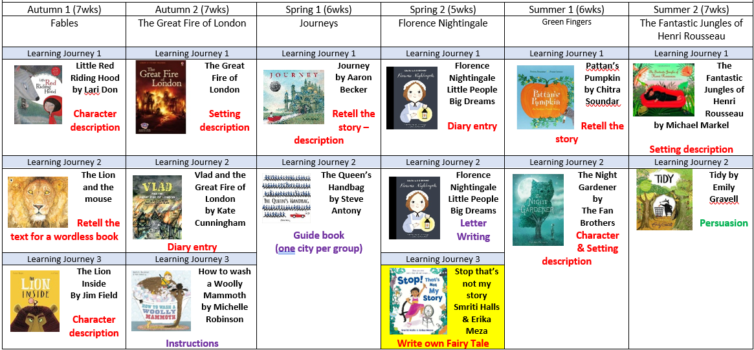
Science | Animals including humans 1/ growth  Describe the needs of humans and animals for survival.  Explore and describe the importance of a balanced diet and exercise. | Animals including humans 2:  Life Cycles  Order and describe the stages of the human life cycle.  Explore the life cycles of animals. | Living things and their habitats/micro-habitats  Identify and name a variety of plants and animals.  Find out about habitats and micro-habitats and what animals eat to survive. | Uses of everyday materials  Identify a variety of everyday materials and their uses.  Understand that different materials are suited for different purposes. | Plants  Find out what plants need to grow and stay healthy.  Describe the life cycle of a plant.  Understand that plants adapt to their environment. | Living things and their habitats around the world  Learn about habitats and appreciate that habitats are constantly changing.
History |  | To investigate and interpret the past.  Observe or handle evidence to ask questions and find answers to questions about the past.  To build an overview of world history.  Describe historical events.  Describe significant people from the past.  Recognise that there are reasons why people in the past acted as they did.  To understand chronology.  Label time lines  Recount changes that have occurred in their own lives. |  | Find out about the lives of significant individuals in the past who have contributed to national and international achievements.  Florence Nightingale  To investigate and interpret the past.  Observe or handle evidence to ask questions and find answers to questions about the past.  To communicate historically  Use words and phrases such as: a long time ago |  | Find out about the lives of significant individuals in the past who have contributed to national and international achievements.  Artists:  Henri Rousseau
Geography |  | Communicate Geographically  Identify the key features of a location in order to say whether it is a city, town, village, coastal or rural area. | To Investigate Places  Use world maps, atlases and globes to identify the United Kingdom and its countries, as well as the countries, continents and oceans studied.  Communicate Geographically  Name, locate, and identify characteristics of the four countries and capital cities of the United Kingdom and its surrounding seas.  Name and locate the world’s continents and oceans.  Use compass directions and locational language (e.g. near and far) to describe the location of features and routes on a map.  Devise a simple map. | Use simple fieldwork and observational skills to study the geography of the school and the key human and physical features.  To Investigate Places  Geography of the school and the key human and physical features. | To Investigate Patterns  Understand geographical similarities and differences through studying the human and  physical geography of a small area of the  United Kingdom and a contrasting non-European country.  Look at plants etc in our gardens and compare with another location
Art | Access Art – Explore & Draw | Access Art Drawing Exercises | Access Art Drawing Exercises | Access Art – Music and Art | Access Art Drawing Exercises | Access Art – Expressive Painting
DT |  |  | Materials  Cut materials safely using tools provided.  Measure and mark out using a range of techniques.  Create products using levers, wheels and winding mechanisms.  Design products that have a clear purpose and intended user.  Make and refine products.  Create a vehicle/mode of transport (wind-up car) | Textiles  Shape textiles using templates.  Join textiles using running stitch.  Colour and decorate textiles using a number of techniques (such as dying, adding sequins or printing)  Easter Puppet | Food  Cut, peel or grate ingredients safely and hygienically.  Measure or weigh using measuring cups or electronic scales.  Assemble or cook ingredients.  Make salad/soup using vegetables from the edible garden
PE | Gym – Basic shapes  Children investigate movement, stillness, and how to perform gymnastic actions on the floor. They copy or create, remember and repeat short movement phrases of 'like' linked actions.  Children will describe how their bodies feel during exercise.  Ball skills – Netball/Basketball  In this unit children improve and apply their basic skills in They play games that demand simple choices and decisions on how to use space to avoid opponents, keep the ball and score points. | Dance  Copy and repeat a sequence of movements, and perform actions and skills with more control and quality. Respond to music with a range of movements.  Fire of London  Ball skills – Hockey/football  Explore different ways of sending a ball using a hockey stick. Develop the skills to control a football close to the foot, and towards a target. | Gym - Apparatus  Children will perform basic shapes on the floor and on apparatus. Children will link movements, by travelling on and off different pieces of equipment.  Invasion Games  They play games that demand simple choices and decisions on how to use space to avoid opponents, keep the ball and score points. | Dance  Children create and perform dances using a range of movement patterns. Children begin to work in small groups to produce a piece for performance.  Throwing and catching  In this unit children improve and apply their basic skills in games. | Net/Wall  Children learn to hit a ball and shuttle with a bat. They will try to hit the ball or shuttle towards a target.  Athletics  Children will demonstrate the basic jumps (2feet to 2 feet, 1 to 2, 1 to 1, 2 to 1).  Children will learn a range of throwing actions. Children will learn to co-ordinate their body movements to run more effectively. | OAA  Teach children how to find objects on a drawing or diagram by recognising symbols. Teach them how to hold or orientate their diagram or map.Children will complete challenges and be taught how to work with a partner  or small group to achieve this.  Striking and fielding  Children will be taught how to hold different bats or rackets, and how to stand to hit the ball.  Teach them how to stand ready as a fielder, eg get low to the ground behind the oncoming ball, cupped hands on the ground to receive the ball.
RE | Theme/Unit: Ideas about God  Key concept: God | Theme/Unit: Light helps people to remember  Why is light important at Advent and Hanukkah  Key Concept: Candle light as a symbol | Theme/Unit: Key events in the life of Jesus  Key Concept: Authority | Theme/Unit: Special food  Key Concept: Special | Theme/Unit: Special books  Key Concept: Special in relation to books | Theme/Unit: Water  Key Concept: Ritual
PSRE | Rights and responsibilities | Feelings and Emotions | Keeping Safe | Diversit | Growing and Changing | Healthy Relationships
Music | Charanga: Exploring simple patterns  Listen To Me  To Compose  *Choose sounds to create an effect.  Sequence sounds to create an overall effect.  Use percussion instruments and natural objects,  Eg. leaves to create a soundscape of autumn animals in the forest.  To Perform  Take part in singing, accurately following the melody.  Follow instructions on how and when to sing or play an instrument.  Make and control long and short sounds, using voice and instruments.  Imitate changes in pitch.  Learn and perform Autumn and Harvest songs using voices and percussion instruments. | Charanga: Dynamics and Tempo  Listen To Me  To Perform*Take part in singing, accurately following the melody.  Song: London’s Burning: Sing in a round  To compose  Create a mixture of different sounds (long and short, loud  and quiet, high and low).  Sequence sounds to create an overall effect.  Create a soundscape of Fire of London. | Charanga: Exploring feelings through music  Listen To Me  To Transcribe  *Use symbols to represent a composition and use them to help with a performance.  In groups create a soundscape of a journey. | Charanga: Inventing and musical story  Listen To Me  Perform in singing assembly | Charanga: Exploring music that makes you dance  Listen To Me | Charanga: Exploring Improvisation  Listen To Me
Computing | Computing Systems and Networks.  IT all around us  Using IT safely and in different ways. | Creating Media  Digital Photography  Taking photographs.  What makes a good photograph?  Lighting and effects | Programming A  Robot Algorithms  Describe a series of instructions as a sequence.  Use logical reasoning to predict the outcome of a programme. | Data and Information  Pictograms  Entering data and creating pictograms.  Comparing and presenting information. | Creating Media  Digital Music  Rhythms and patterns, notes and tempo.  Create music.  Review and edit music. | Programming B  Programming Quizzes  Creating and reviewing a design.

