 | Year 3 Curriculum 2025-2026
 | Autumn 1 | Autumn 2 | Spring 1 | Spring 2 | Summer 1 | Summer 2
Project title | Stone Age vs Iron Age | Wild Robot | Healthy Habits | Brilliant Oliver’s Battery | A European Adventure | Ancient Egypt
Key Question | How did the Stone Age people affect our lives? | How do magnets work? | How can I take care of marvellous me? | What makes Oliver’s Battery so great? | Where would you like to visit? | How do we know about Ancient Egypt?
Driver | History | Science | Science | Geography | Geography | History
Hook | Selection of artefacts | Hunt for the Wild Robot | What do you do to keep healthy? | An adventure in Oliver’s Battery | Country treasure hunt | Explore Egyptians artefacts
Outcome | Stone Age Day  Cave paintings | Make magnetic games | Healthy fitness day | Information leaflets for people new to the area. | Taking Year R on a European adventure | Egyptian activity day
Enrichment opportunities | Virtual tour of Stonehenge | Challenge Year 5 to play magnetic games | Share healthy habits with KS1  Forest School | Local walks and Winchester trip Edible playground | Edible playground  Exhibit for parents | Creating Egyptian clothing  Edible playground
Key texts | The Secrets of Stonehenge by Mick Manning  Stone Age Boy by Satoshi Kitamura | Until I met Dudley by Roger McGough  Wild Robot by Peter Brown | Werewolf club rules by Joseph Coelho  Tidy by Emily Gravett | Street beneath my feet by Charlotte Guillian  The pebble in my pocket by Meredith Hooper | The people award by Lily Murray  Arthur and the goilden rope | Marcy and the riddle of the sphinx by Joe Todd Stanton  Egyptian Cinderella by Shirley Climo
English writing genres | 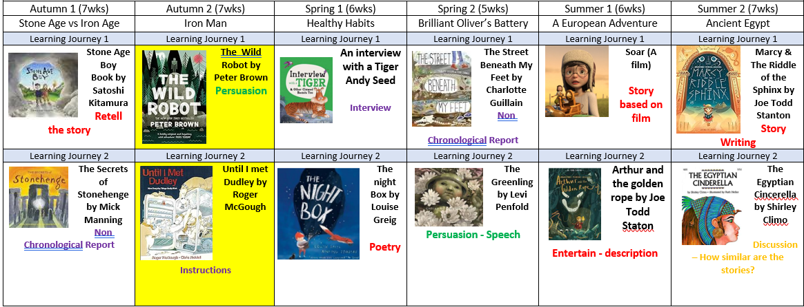
Science | Longitudinal study  Light | Forces | Longitudinal study (part 2)  Animals including humans | Rocks | Longitudinal study (part 3)  Scientific Enquiry | Plants
History | Use evidence to ask questions about the past  Use dates and terms to describe events |  |  | Give a broad overview of changes of life in Britain Describe the changes throughout history regarding the locality of the school |  | How do these early civilisations fit within world history?  What made the river nile so important?
Geography |  |  |  | Physical geography: describe the characteristics of an area.  - Human geography: how an area can be affected | Name and locate countries Using maps and atlases to locate countries and continents | Use fieldwork to observe, measure, record and present the human and physical features in the local area using a range of methods, including sketch maps, plans and graphs, and digital technologies.
Art | Charcoal drawings |  | Moving animal puppets |  | Sculptural clay
Design Technology |  | Make magnetic games |  | Mechanisms and levers |  | Textiles
PE | Dance  Invasion games | Swimming  Hockey | Forest School | Gymnastics  Football | Athletics  Cricket | Tennis  Rounders
PSHE | Living in the wider world | Relationships | Health and Well- being | Living in the wider world | Relationships | Living in the wider world
RE | Diwali- Good and Evil | Angels | Making choices- temptation | Paschal Candle- Rituals | Hindu worship- Devotion | Hindu worship- Devotion
Music | Charanga- Notational skills | Charanga- Improvisation and enjoying | Charanga- Composing and playing | Charanga- Sharing musical experiences | Charanga- Learning music styles | Charanga- Recognising different sounds
Computing | Computing systems and networks- | Creating media- stop motion animation | Programming- Sequencing sounds | Data and information- Creating databases | Creating media-  Desk top publishing | Programming- Events and actions in programmes
French | Where is France?  French greetings  Numbers 1-20 | French alphabet  Colours  Christmas | Days of the week  Months of the year  French celebrations | Talk about home  Pets  Visit to a cafe | Our body  Clothes we wear  Weather | Holidays  How to travel  Sports/ hobbies

Y 3 | Stone Age  Stone Age Britain: what do archaeologists think they know about it? (6 lessons)  Stone Age to Iron Age Britain | Iron Man  Iron Age Britain: what have historians learnt about Iron Age Britain? (6 lessons) | A European Adventure | Brilliant Oliver’s Battery | Healthy Habits | Ancient Egypt  Ancient Egypt: what stayed the same across 3,000 years? (6 lessons)  (Earliest Civilisations: Ancient Egyptians)

Y 3 | Stone Age to Iron Age | Iron Man | A European Adventure  Europe: how diverse are its landscapes and places? (6 lessons)  Europe: what is it like to live in northern Italy? (6 lessons)  Can condense down from 12 | Brilliant Oliver’s Battery  Settlements: where do people live and why?  (6 lessons)  2 extra lessons just on Oli b | Healthy Habits | Ancient Egypt

