
OLIVER’S BATTERY LONG TERM CURRICULUM PLANNING 2025-26

Year Group: 4 | Autumn 1 |  | Autumn 2 |  | Spring 1 |  | Spring 2 |  | Summer 1and  Summer 2
Project title | Water World  Rivers, Mountains and Coast |  | Rotten Romans |  | Invaders and Settlers |  | St Lucia |  | Habitats and Conservation
Key question | Why is water important? |  | What did the Romans leave behind? |  | Who ruled best? – Vikings or Saxons? |  | Where in the World? |  | What is a Habitat and how can we preserve them?
Driver | Geography |  | History |  | History |  | Geography |  | Science
Hook | Go and explore the pond, describe the scene and wildlife seen. |  | Hook – solve own mystery – clues around the school |  | Bayeux Tapestry mural making day. |  | Google Meet chat with Resident from St.Lucia |  | Go into edible gardens and walk around the school on a flower hunt.
Outcome | Make a model of a river/water cycle |  | To entertain (build suspense/tension – Roman Mysteries story writing (using Thieves of Ostia)  To inform – factual writing for Romans information book |  | Art show including our mural and sculptures. |  | To write a sequel to Gregory’s Cool |  | Make a bug hotel.
Enrichment opportunities |  |  | Fishbourne Roman Palace
English | 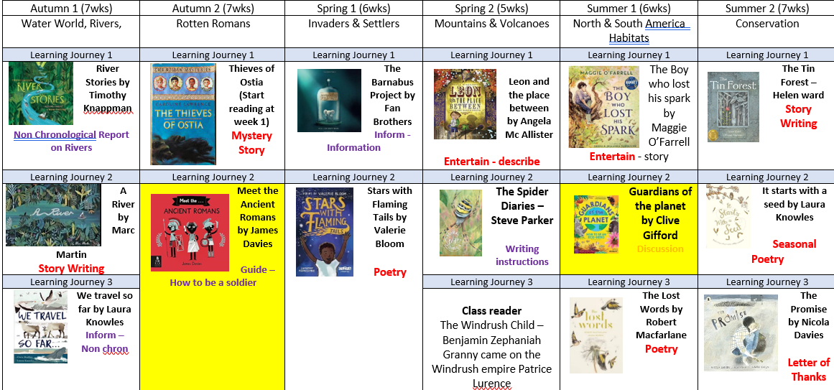
Science | Solids, liquids and gases  Changing state, melting, freezing, boiling  Compare and group materials together according to whether they are solid liquid or gases.  Lesson 4 & 5 of Living things and their habitats – Conservation about saving water and water pollution.  (Developing Experts) |  | Digestion – Animals including humans. Animals need a variety of foods to help them grow and survive.  The role of digestion in the human body.  Human and animal teeth.  (Developing Experts) |  | Making electrical circuits  Identify common appliances that run on electricity.  Construct a simple series electrical circuit.  Recognise some common conductors and insulators, and associate metals with being good conductors.  (Developing Experts) |  | Sound  Identify how sounds are made.  Explore how vibrations from sounds travel through a medium to the ear. |  | Living Things and their habitats – conservation.  Describe ecosystems and how they are affected by changes in the seasons.  Understand human impact on the environment through deforestation.  Excluding Lessons 4 & 5  (Developing Experts)  Living Things and their habitats  Identify characteristics of living things  Explore different habitats.  Explore how animals can be classified.  Adaptations
History |  |  | History:  Roman Empire & impact on Britain:  How Roman control expanded over Europe.  Why invade Britain?  Exploring aspects of Romanisation and its impact.  What has changed, what’s the same?  Exploring aspects of long term impact of the Roman Empire. |  | History  -Viking and Saxon raids and invasion  -Suggest suitable sources of evidence for historical enquiry  -Describe different accounts of a historical event  -Give an overview of life in Britain from ancient until Medieval times.
Geography | Key physical features, including beach, coast, forest, hill, mountain, ocean, river, soil, valley, vegetation and weather.  - Key human features, including: city, town, village, factory, farm, house, office and shop.  Identify key aspects of physical geography including rivers, mountains and the water cycle.  Make mountain and river.  Water cycle  Use the eight points of a compass, four-figure grid references, symbols and key to communicate knowledge of the United Kingdom and the wider world. |  | Locate and name countries – focus on Roman Empire and Europe, (name changes, link to Roman invasion and empire) trade and settlements |  |  |  | Use maps, atlases, globes and digital/computer mapping to locate countries and describe the features.  Name and locate countries and cities of the United Kingdom, geographical regions and their identifying human and physical characteristics, including hills, mountains, cities, rivers.  Name and locate the Equator, Northern Hemisphere, Southern Hemisphere, The  Tropics of Cancer and Capricorn, the Artic and Antarctic Circles and date and time zones.  Describe geographical similarities and differences between countries.  Physical geography, including: rivers, mountains, volcanoes.  Use the eight points of a compass, four-figure grid references, symbols and key to communicate knowledge of the United Kingdom and the wider world. |  | Use fieldwork to observe and record the human and physical features in the local area using a range of methods including sketch maps, plans and graphs and digital technologies.
Art | Take Inspiration from the Greats  Looking at famous water colour artists – Monet, Dali and  Use pastels to create pictures in the style of these artist.  Replicate techniques and pieces of art made by others.  Create original pieces influences by the study of others.  Study the use of watercolours. |  | AccessArt:  Exploring Pattern  Artists:  Rachel Parker, Shaheen Ahmed, Andy Gilmore, Louise Despont  Collage  Roman mosaics – Collage.  Explore collage with different materials. |  | Sculpture  Use inspiration from famous sculpture Alberto Giocometi to create wire scuptures of men in Bayeaux Tapestry. |  |  |  | Access Art  Disciplines: Drawing, Sketchbooks, Sculpture  Pathway: Sculpture, Structure, Inventiveness, Determination  Aims of the Pathway  This pathway aims to provide children with the opportunity to connect drawing and making, encouraging the freedom to be inventive and exploratory. The processes involved ask children to take creative risks, and to feel ok if they feel challenged by creating art.
DT |  |  |  |  | Projects on a page: Simple circuits and switches  Discuss, investigate and, where practical, disassemble different examples of relevant battery-powered  products, including those which are commercially available e.g. Where and why they are used? How  does the product work? What are its key features and components? How does the switch work? Is the  product manually controlled or controlled by a computer? What materials have been used and why?  How is it suited to its intended user and purpose? |  | Projects on a page: health and varied diet  Children investigate a range of food products e.g. the content of their lunchboxes over a week, a  selection of foods provided for them, food from a visit to a local shop. Link to the principles of a varied  and healthy diet using The eatwell plate e.g. What ingredients have been used? Which food groups do  they belong to? What substances are used in the products e.g. nutrients, water and fibre? |  | Aspect of D&T  Structures Focus: Shell structures  Project title  Design, make and evaluate a minibeast hotel (product) for insects (user) for creating a habitat (purpose).  Cut materials accurately and safely by selecting appropriate tools.  Measure and mark out to the nearest millimetre.  Apply appropriate cutting and shaping techniques that include cuts within the perimeter of the material (such as slots or cut-outs).  Select appropriate joining techniques.  Choose suitable techniques to construct products or to repair items.  Strengthen materials using suitable techniques.  Use scientific knowledge of the transference of forces to choose appropriate mechanisms for a product.
PE | Dance - Water World  The children watch video clips and discuss the stimulus and use language to describe it, exploring these action words through different movements.  The children will be encouraged to respond imaginatively to a variety of stimuli.  Invasion Games  To understand the concept of attack and defence. In all games activities, children think about how to use skills, strategies and tactics to outwit the opposition. | Gym basic shapes  Children should practise agilities and actions from the basic shapes that they can include in their sequence. Help them to perform different combinations of these. Teach them how to perform these combinations with a change of speed, level and direction.  Tag Rugby  Children will be taught to pass the Rugby ball correctly, behind them. They will learn to dodge opponents and chase for a Tag. Small-sided games will be played and scoring introduced. |  | Dance - Invasions - Vikings and Saxons  The children will translate ideas from a variety of stimuli. They will begin to create longer dances/motifs and work in small groups and whole class to prepare a piece for performance.  Basketball/Netball  Children should understand the need for a warm up and describe what effect a running warm-up has on their body. Children will dribble a basketball with control. They will learn to footwork rule and pass the ball effectively. Children will begin to link passing, dribbling and shooting in a game situation. |  | Gym Apparatus  Children will be imaginative in apparatus layout, and create a sequence on and around the equipment.  Children can suggest why the layout is safe and suitable for the activity. (ie a bench and mat to display jumping.)  Football/Hockey  Children will use a range of sending, receiving and travelling techniques to move the ball independently and in a small-sided game. |  | Athletics  Children will explore different ways of running jumping and throwing.  Children will feel the difference between running faster and slower over longer distances, and the affect it has on their breathing.  Crickets skills - Striking and fielding  Children will learn to strike a ball with a Rounders and Cricket bat and throw the ball accurately towards a target when bowling and fielding. Children will learn to intercept and  stop a ball, then return it quickly. |  | Outdoor and adventurous activities.  Orienteering activities – mapwork skills.  Striking and fielding – rounders and tennis
RE | Ceremonies – funerals, baptism  Autumn leaves  Vicar visit | Christmas: The Annunciation (visit of the Angel Gabriel to Mary to announce the Incarnation). |  | Holi – Good and Evil |  | Trees - Symbolism |  | How do people perceive God? |  | Christian miracle stories about Jesus
PSRE | Rights and responsibilities (LWW) | Anti-Bullying – Prejudice (R) |  | Alcohol and Tobacco (H&W) |  | Secrets (R) |  | Diversity (LWW) |  | People and the Media (H&W)
Music | Listen To Me  Play notes on an instrument with care so that they are clear.  Use the terms: duration, timbre, pitch, beat, tempo and texture.  Recognise the notes EGBDF and FACE.  Evaluate music using musical vocabulary.  Charanga  Musical structures | Listen To Me  Play notes on an instrument with care so that they are clear.  Use the terms: duration, timbre, pitch, beat, tempo and texture.  Recognise the notes EGBDF and FACE.  Evaluate music using musical vocabulary.  Charanga  Exploring feelings when you play. |  | Listen To Me  Play notes on an instrument with care so that they are clear.  Use the terms: duration, timbre, pitch, beat, tempo and texture.  Recognise the notes EGBDF and FACE.  Evaluate music using musical vocabulary.  Charanga  Compose with your friends. |  | Listen To Me  Play notes on an instrument with care so that they are clear.  Use the terms: duration, timbre, pitch, beat, tempo and texture.  Recognise the notes EGBDF and FACE.  Evaluate music using musical vocabulary.  Explore different techniques for playing a variety of percussion.  Develop use of Ostinato – short repeated patterns.  Charanga  Feelings through music |  | Listen To Me  Play notes on an instrument with care so that they are clear.  Use the terms: duration, timbre, pitch, beat, tempo and texture.  Recognise the notes EGBDF and FACE.  Evaluate music using musical vocabulary.  Explore different techniques for playing a variety of percussion.  Develop use of Ostinato – short repeated patterns.  Charanga  Expression and improvisation |  | Listen To Me  Play notes on an instrument with care so that they are clear.  Use the terms: duration, timbre, pitch, beat, tempo and texture.  Recognise the notes EGBDF and FACE.  Evaluate music using musical vocabulary.  Charanga  The show must go on.
Computing | Computing systems and networks | Creating media – audio production |  | Programming – Repetition of shapes |  | Data Information |  | Photo editing |  | Programming – Repetition in Games
MFL | Start to understand cultural similarities and differences and how festivals are celebrated  Respond to simple questions with support from a spoken model or visual clue  Respond to spoken instructions | Recognise numbers 1–20  Colours |  | Begin to know some key vocabulary e.g. body parts  countries and towns. |  |  |  | Research additional vocabulary using a dictionary  Days of the week, months. |  | Remember a sequence of spoken words  Speak clearly and confidently Initiate a conversation when working with a partner

