OLIVER’S BATTERY LONG TERM CURRICULUM PLANNING (Year 5)

Year Group: | Autumn 1 | Autumn 2 | Spring 1 | Spring 2 | Summer 1 | Summer 2
Project title | Pole to Pole | Beyond the Earth | The Ancient World  Ancient Sumer, Indus Valley, Maya, Egyptians and Shang Dynasty | Ancient Greece  Legacy and impact on the western world | Heroes of Humanity | Global Citizens
Key question | What can the Earth provide for us? | What lies beyond the Earth’s atmosphere? | How did ancient civilisations impact today’s world? | What did the Greeks do for us?  How have so many aspects of Ancient Greek culture survived until today? | How do we power the world? | Does it matter how we live?
Driver | Geography | Science | History  Geography | History | Geography  P4C/PSRE | Geography  PSRE
Hook | School grounds survey -how well do we utilise our school grounds? | BBC Earth Science – Eight Wonders of Our Solar System |  | History artefact box – Hampshire County Council | Residential to Ferny Croft – stepping out of our comfort zones, being brave, teamwork | Around the world in 60 seconds
Outcome | Plan an expedition to Antarctica | Create a class tapestry (patchwork) which depicts our views of Planet Earth | Class Museum – create exhibitions and invite other classes to visit |  | Visitor from a local renewable energy company | Global Café – outcome event to parents
Enrichment opportunities | Edible Playground  Forest school | Edible playground  Winchester Science Centre and Planetarium | Edible Playground | Edible Playground  Ancient Greece style Olympic Games | Edible Playground  Residential  Tasting food from around the world (DT) | Edible Playground  MHST Mental Health Workshops  St Swithuns ‘Play in a Day’  Kings Production Dress Rehearsal
Key texts | 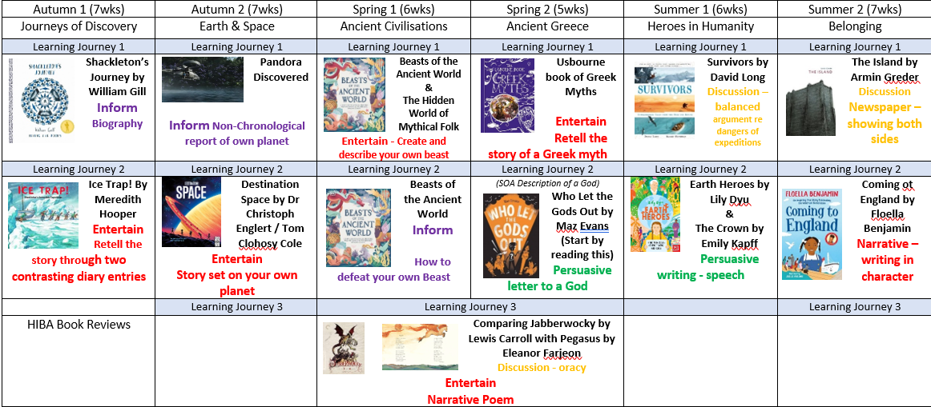
Reading for Pleasure | Beyond the Frozen Horizon by Nicola Penfold  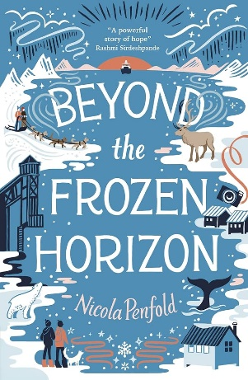 | The Jamie Drake Equation by Christopher Edge  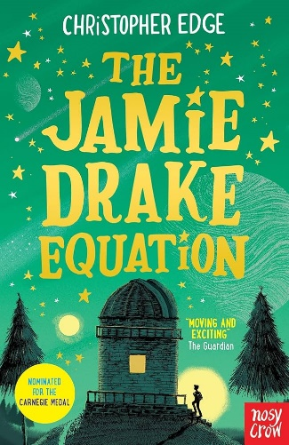 | Mythopedia by Becky Bolton and Louise Chappell  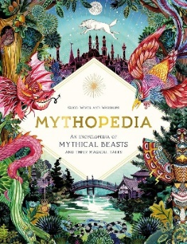  Ancient civilisations reading comprehension texts | Adventures of Odysseus by Hugh Lupton  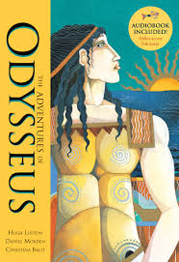  The Shadow of the Minotaur by Alan Gibbons  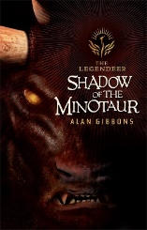 | How to live forever by Colin Thompson  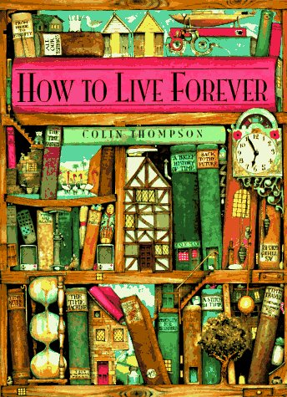 | The Girl Who Stole An Elephant by Nizrana Farook  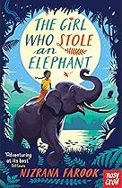
English writing genres | Inform: Biography  Entertain: Two contrasting diary entries | Inform: Non-Chronological report of own planet  Entertain: Story set on your own planet | Entertain:  Create and describe your own beast  Inform: How to defeat your own Beast | Entertain:  Retell the story of a Greek myth  Persuade: Persuasive letter to a God | Discussion – balanced argument regarding dangers of expeditions  Persuasive writing - speech | Discussion: Newspaper report – showing both sides of the story  Narrative: Writing in character
Science  As a school we follow the developing expert programme  https://www.developingexperts.com/ | Science- Living things and their habitats  Describe the differences in the life cycles of a mammal, an amphibian, an insect and a bird  Describe the life process of reproduction in some plants and animals  Longitudinal study begins- How we change and grow over time | Science – Space & gravity  Describe the Sun, Earth and Moon as approximately spherical bodies  Use the idea of the Earth’s rotation to explain day and night and the apparent movement of the Sun across the sky | Science – Forces:  Explain that unsupported objects fall towards the Earth because of the force of gravity acting between the Earth and the falling object  Recognise that some mechanisms including levers, pulleys and gears allow a smaller force to have a greater effect  Longitudinal study  (part 2) | Science- Properties of materials  Compare and group together everyday materials based on evidence from comparative and fair tests, including their conductivity of heat  Give reasons, based on evidence from comparative and fair tests, for the particular uses of everyday materials, including metals, wood and plastic | Science- Changes in materials  Describe how to recover a substance from a solution  Explain that some changes result in the formation of new materials, and that this kind of change is not usually reversible  Longitudinal study  (part 2) | Science – Animal including humans  Describe the changes as humans develop to old age. Describe we change during puberty. Explore the gestational processes of humans and animals.
History | Ernest Shackleton’s expedition  Link to other events happening around the world – WW1, women’s rights – how was the world evolving? |  | Sumer and other early civilisations: what made them similar? | Ancient Greek civilisation: what is its most significant legacy?
Geography | Natural resources: what are they, where are they found, why are they important?  Climate zones: what are they and why do they matter? |  |  |  | Energy: how do we power the world?  Time zones: can we time travel on planet Earth? | Sustainable world: does it matter how we live?
Art | Typography & Maps  Exploring how we can create typography through drawing and design, and use our skills to create personal and highly visual maps | Drawing exercises | Mixed Media Land & City Scapes  Explore how artists use a variety of media to capture spirit of the place | Drawing exercises | Drawing exercises | Making Monotypes  Combine the monotype process with painting and collage to make visual poetry zines.
DT |  | Textiles – Combining different fabric shapes  Designing  • Generate innovative ideas by carrying out research including surveys, interviews and questionnaires.  • Develop, model and communicate ideas through talking, drawing, templates, mock-ups and prototypes and, where appropriate, computer-aided design.  • Design purposeful, functional, appealing products for the intended user that are fit for purpose based on a simple design specification.  Making  • Produce detailed lists of equipment and fabrics relevant to their tasks.  • Formulate step-by-step plans and, if appropriate, allocate tasks within a team.  • Select from and use a range of tools and equipment to make products that are accurately assembled and well finished. Work within the constraints of time, resources and cost.  Evaluating  • Investigate and analyse textile products linked to their final product.  • Compare the final product to the original design specification.  • Test products with intended user and critically evaluate the quality of the design, manufacture, functionality and fitness for purpose.  • Consider the views of others to improve their work.  Technical knowledge and understanding  • A 3-D textile product can be made from a combination of accurately made pattern pieces, fabric shapes and different fabrics.  • Fabrics can be strengthened, stiffened and reinforced where appropriate. |  | Mechanisms – Pulleys or gears  Designing  • Generate innovative ideas by carrying out research using surveys, interviews, questionnaires and web-based resources.  • Develop a simple design specification to guide their thinking.  • Develop and communicate ideas through discussion, annotated drawings, exploded drawings and drawings from different views.  Making  • Produce detailed lists of tools, equipment and materials. Formulate step-by-step plans and, if appropriate, allocate tasks within a team.  • Select from and use a range of tools and equipment to make products that that are accurately assembled and well finished. Work within the constraints of time, resources and cost.  Evaluating  • Compare the final product to the original design specification.  • Test products with intended user and critically evaluate the quality of the design, manufacture, functionality and fitness for purpose.  • Consider the views of others to improve their work.  • Investigate famous manufacturing and engineering companies relevant to the project.  Technical knowledge and understanding  • Understand that mechanical and electrical systems have an input, process and an output.  • Understand how gears and pulleys can be used to speed up, slow down or change the direction of movement.  • Know and use technical vocabulary relevant to the project. | Food – celebrating culture and seasonality  Designing:  • Generate innovative ideas through research and discussion with peers and adults to develop a design brief and criteria for a design specification.  • Explore a range of initial ideas, and make design decisions to develop a final product linked to user and purpose.  • Use words, annotated sketches and information and communication technology as appropriate to develop and communicate ideas.  Making  • Write a step-by-step recipe, including a list of ingredients, equipment and utensils  • Select and use appropriate utensils and equipment accurately to measure and combine appropriate ingredients.  • Make, decorate and present the food product appropriately for the intended user and purpose.  Evaluating  • Carry out sensory evaluations of a range of relevant products and ingredients. Record the evaluations using e.g. tables/graphs/charts such as star diagrams.  • Evaluate the final product with reference back to the design brief and design specification, taking into account the views of others when identifying improvements.  • Understand how key chefs have influenced eating habits to promote varied and healthy diets.  Technical knowledge and understanding  • Know how to use utensils and equipment including heat sources to prepare and cook food.  • Understand about seasonality in relation to food products and the source of different food products.  • Know and use relevant technical and sensory vocabulary.
PE | (INDOOR)  Gym – Basic Shapes  (OUTDOOR)  Forest School | (INDOOR)  Dance – street dance  (OUTDOOR)  Invasion games, then Football | (INDOOR)  Gym – Partner Balance  (OUTDOOR)  Netball and basketball | (INDOOR)  Dance – contemporary dance  (OUTDOOR)  Hockey | ALL PE OUTDOORS  Cricket- Striking and fielding  Athletics | ALL OUTDOORS PE  Rounders- Striking and fielding  Wide games- Team building  Badminton
RE | Creation Stories (Stewardship) | The Magi (Prophecy) | Places of Worship (Sacred Places)  - | Jesus, his teachings and his messages (What can we discover about the message of Jesus?) | Making decisions  Concept of persuasion within religion | Prayer (Ritual)
PSRE | Being me in my world  - British values  - Roles and responsibilities | Celebrating Difference  - Racism  - Money  - Rumours and name calling  - Bullying | Dreams and Goals  - Careers  - Dreams and goals of young people in other cultures | Healthy Me  - Smoking/alcohol  - Emergency aid  - Body image and relationships with food | Relationships  - Conflict resolution  - Girlfriends and boyfriends  - Relationships and technology | Changing Me  - Puberty  - Conception  - Age of consent
Music  As a school we follow the charanga programme  https://charanga.com/site/ | Sing and perform  Understand the importance of warming up your voice.  Share a performance with an audience  Understand the importance of a good singing posture |  | Improvisation and composition  Pulse, rhythm and pitch- create own piece of music  *Listen to me sessions to take place* |  | Play a musical instrument in the correct context of the unit song  Consolidating and practising good Singing posture- importance of our lungs
Computing | Computing systems and networks | Creating media – video production | Programming A – Selection in physical computing | Data and information – flat file databases | Creating media – Introduction to vector graphics | Programming B – Selection in quizzes
MFL | - French Festivals  - Numbers beyond 100 | - My family and friends  - Homes and streets | - Colours and shades  - Animals | - Healthy food  - Telling the time | - Clothing and outfits  - Money and change | - Holidays  - Towns and cities

