
Curriculum Map Year 6 202 5-26
Year Group: | Autumn 1 |  | Autumn 2 | Spring 1 | Spring 2 | Summer 1 | Summer 2
Project title | Evolution | A Childs War |  | Our Changing Planet – Climate Change | Crime & Punishment 1900 to modern day | Around the world in 80 days/ SATs | Early Islamic Civilisation
Key question | Where did we come from? | How does war impact children’s lives and their rights?  Why was the Battle of Britain a significant turning point in British history? |  | How is our world changing? | Has the way we catch and punish criminals improved since Anglo-Saxon Times? | Where are you ? | What made the Early Islamic Civilisation a beacon of light in the Dark Ages?
Driver | Science | History and Geography |  | PSHE and Science, Geography | History | Geography | History and Geography
Hook | Excavation of fossils | Suitcases with artefacts  Goodnight Mr Tom - film |  | Local field work - our local area |  |  | Silk Road Souk Experience  (sounds, smells, sights)  Sinbad the Sailor animation
Outcome | Museum exhibition for parents | Celebration ‘street’ party – VE Day Style |  |  |  | Travel blogs to share | Write our own myth
Enrichment opportunities | Science workshop  (Natural History Museum - online)  Calshot Residential | Winchester War Museums trip |  | Visitor to speak about Everest – Sarah Witt |  |  | Year 6 Graduation  Enterprise treat
Key texts | 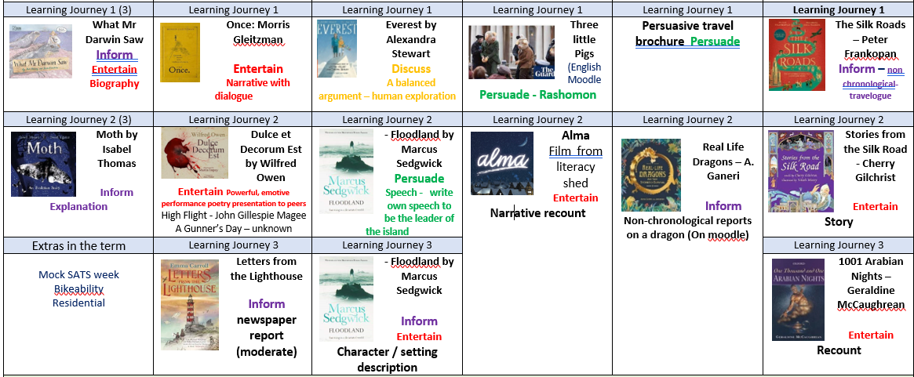
Science  developing expert programme  https://www.developingexperts.com/ | Evolution and Inheritance:  Identify inherited traits and apply knowledge to various animals and plants; study Mary Anning and Charles Darwin; learn about the history of the human race and discover links between extinct animals and those which are still living today. |  | Living things and their habitats:  Identify the kingdoms of life; classify living things within those kingdoms; Explore the Linnean system of classification and develop practical scientific skills though investigating mould growth on bread and mushroom spore dispersal. | Looking after our environment:  What the climate is, how it changes, the difference between a man-made and natural environment and where different types of animals live. | Light:  Recognise that light appears to travel in straight lines; use this idea to explain that objects are seen because they give out or reflect light into the eye; explore how light travels to enable us to see; explain why shadows have the same shape as the objects that cast them | Electricity:  Associate the brightness of a lamp or the volume of a buzzer with the number and voltage of cells used in the circuit; compare and give reasons for variations in how components function; use recognised symbols when representing a simple circuit in a diagram. | Science: Humans  Identify and name the main parts of the human circulatory system, and describe their functions; recognise the impact of diet, exercise, drugs and lifestyle; and describe the ways in which nutrients and water are transported within animals, including humans.
History | - Use sources of evidence to deduce information about the past – fossils, photographs, stories  - Mary Anning: Key figure in local history (South Coast)  - The Fossil Record: What does it tell us about the past? | - The Battle of Britain  - A significant turning point in British history  Local history study – Winchester / Hants in the war  - Using maps to focus on Europe (Russia), locate/name countries & major cities  - Name and locate key counties and cities of the United Kingdom  - Maps of the bombings, ports –why were these places targets?  - Propaganda and bias – understanding the social context |  |  | Understand the systems of justice and punishment in Anglo-Saxon, Tudor, Victorian, and modern times.  Compare and contrast how crime was dealt with over time.  Use historical evidence to evaluate whether there has been progress in law enforcement and punishment.  Understand concepts of fairness and justice across different historical periods.  Develop critical thinking through source analysis and interpretation. |  | A non-European society that provides contrasts with British history – early Islamic civilisation
Geography | Galapagos islands – comparison with the UK.  - Use the 8 points of a compass  -Characteristics of South American countries  - Climate zones/biomes  - Use maps, atlases, globes and digital/computer mapping | Human geography,  - types of settlement and land use, economic activity including trade links, and the distribution of natural resources including energy, food, minerals and water  Studying maps of the war and evacuee routes |  | Human geography  How locations around the world are changing and explain some of the reasons for change.  Use fieldwork sampling (random and systematic) to observe, measure and record the human and physical features in the local area. Record the results in a range of ways. |  |  | Human Geography  - Mapping the Silk Road and the involved countries  - Physical geography – what makes a journey more difficult e.g. terrain/bodies of water  - Human geography – settlements along the Silk Road
Art | 2D drawing to 3D making.  Design and make a dragon’s eye:  - Clay modelling/sculpture  - Sketching – tone, texture and detail  Artist study: Beate Kuhn – clay, sculpture  Access Art - Activism |  |  | Access Art - Brave Colour |  |  | Access Art – Exploring Identity
DT |  | Structures  Projects on page: Frame structure  Air raid shelters  Food: Projects on Page  Cook / bake scones and cakes for VE Day Celebration |  |  | Design, make and evaluate a colourful installation piece of art in miniature / model | Electrical systems  Focus  More complex  switches and circuits  Make a lantern as in 80 days around the world.  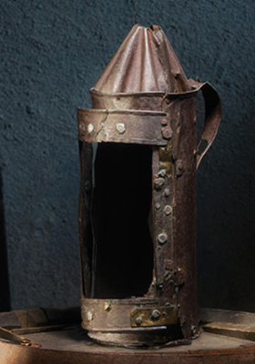 | -
PE | Gymnastics - Shapes  The children will use their knowledge of basic shapes to create and perform sequences to other year groups.  Invasion Games  To be able to move quickly away from defenders. To be able to pass a ball to gain space |  | Dance - War - The Haka  Explore a range of symmetric and asymmetric actions, shapes and balances.  Hockey  Children will pass the ball accurately and with speed. They will attack by dodging defenders and scoring, know how to keep a strong defensive line.  Cricket  External coaches | Health and Fitness - Circuits  Be aware of the changes their body goes through when they take part in physical activities. Children will focus on specific areas of the body to exercise. Focus on co-ordination, balance, flexibility and strength.  Basketball  Children will link skills such as passing, dribbling and shooting, and apply them accurately and appropriately in a game situation. Children will compare and comment on the skills they perform and that of others, offering advice to improve performance. They will compare and comment on the skills they perform and that of others, offering advice to improve performance. | Gymnastics - Apparatus  The children will create longer sequences on the apparatus in small groups, working cooperatively. Practise and perform in front of another class.  Football  Children should pass, dribble and shoot with control and use tactics to help their team keep the ball and take it towards the opposition’s goal. | Rounders  Children will learn to strike a ball with a rounders bat and throw the ball accurately towards a target when bowling and fielding.  Athletics  Children will learn to run at a steady pace. They will explore how to improve their performance in all areas of athletics. | Rounders  Children will learn to strike a ball with a rounders bat and throw the ball accurately towards a target when bowling and fielding.  Net/Wall  Badminton and tennis  To play a game and learn to score a badminton match up to 15. Winner of the point serves.  Continue to practise rallying forehand and backhand
RE | Making Decisions (Persuasion) |  | The two birth  narratives  (Interpretation) | The Empty Cross (Resurrection) | Jesus through Art (Imagery) | Eid-ul-Adha  (Sacrifice) | Flight (Flight as a symbol)
PSRE | Sex and Relationships (R)  - There are many types of loving relationships  - How babies are made and born  Ways to avoid pregnancy |  | Anti-Bullying (R)  - Differences  - Stereotypes / judgements  - Different religions / tolerance  - Protected characteristics | Rights & Responsibilities (LWW)  - Houses of Parliament  - Political parties  - Voting  - Competing priorities in society  - Taxes | Your voice (LWW)  - Human rights / violation of rights  - Pressure groups  How to effect social change | Mental Health (H&W)  - Mental health / wealth  - Effect of poor mental health  - Effect of physical health, sleep, diet on mental health  - Where to get help from to support mental health | Moving on (LWW)  How change feels  Setting aspirations and goals  Independence
Music  charanga programme  https://charanga.com/site/ | Charanga:  Developing Melodic Phrases |  | Charanga:  Understanding Structure & Form  Perform War songs | Charanga:  Gaining Confidence Through Performance  - Musicians and musical careers | Charanga:  Exploring Notation Further  - Study the lyrics Hakka - meanings | Hampshire Music Service – Bamboo Tamboo | Hampshire Music Service – Bamboo Tamboo  Perform and sing – Year 6 production
Computing  (Teach computing) | Computing Systems and Networks – communication & collaboration |  | Creating Media – web pages | Programming – variables in games | Data and information - spreadsheets | Creating Media – 3D modelling | Programming – sensing movement
MFL  (classroom secrets) | Formal & informal  French history  Calculations |  | In the community  At the hospital  French homes | Shades and objects  All about animals  Ordering food | Dates & times  What I’m wearing  Shopping | Holiday plans  Towns & cities  Seasons & Planets | Sports & the Olympics  School and the future

