
OLIVER’S BATTERY LONG TERM CURRICULUM OVERVIEW YEAR R
Whilst some seasonal drivers are planned for each year the majority of themes are based on observations of the children’s interests. Key texts are chosen that support these themes
Year Group: R | Autumn 1 | Autumn 2 | Spring 1 | Spring 2 | Summer 1 | Summer 2
Seasonal drivers | Starting school Getting to know you  Autumn | Halloween  Bonfire Night  Remembrance day  https://www.youtube.com/watch?v=pv_ub7Be7oA  Christmas | Winter  Chinese New Year | Spring  Shrove Tuesday  World Book Day  Fair Trade fortnight  Science Week  Easter |  | Summer  Working Together  Moving up
Key Question | What makes me a me? | What is the Christmas story? | What happens in the winter? | How have I changed? | What’s in our pond? | What do grown-ups do all day?
Themes  Based on seasonal drivers and children’s interests | Starting school  Autumn  Sukkot  Squirrels  Changing season - leaves | Witches Kitchen  Super Heroes  Birthdays  Christmas | Winter  Pets and vets  Lunar New Year | Babies and Parents – animals and human  Nursery Rhymes | Tadpoles  Hatching eggs  Animal habitats Looking after our world | Growing up  What’s it like to live in a different country?
Key texts | 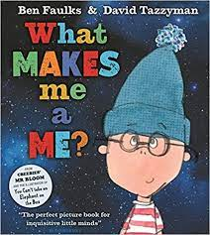  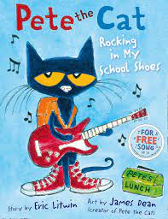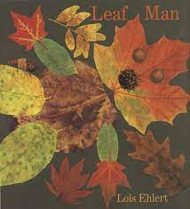  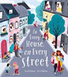 | 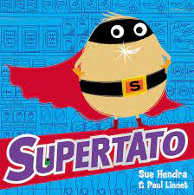  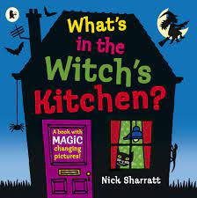  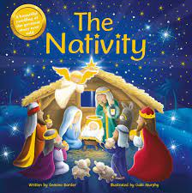 | 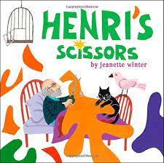  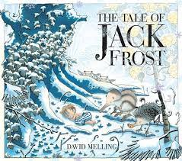  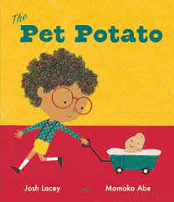  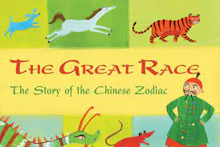 | 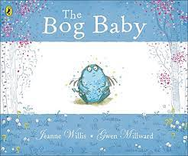  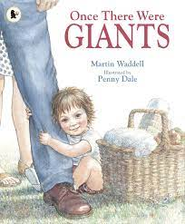  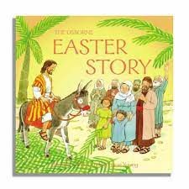  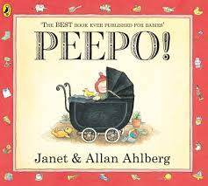 | 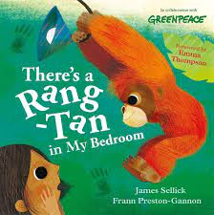  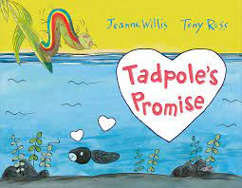  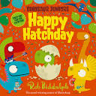  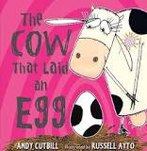 | 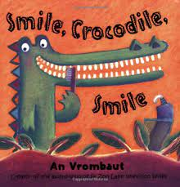  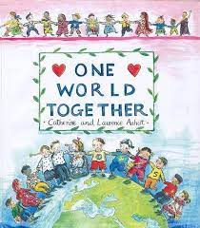  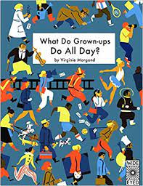  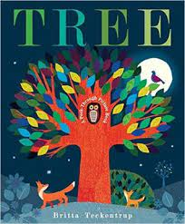
Aspirational Curriculum Goal:  To actively care for the outdoor environment of the school and be able to talk about the importance of this for the sustainability of our community. | Explore the natural world around them at Forest School, for example, through bug hunting, observing the effect of the changing seasons on the environment etc  Participate in tidying up the Early Years outdoor area. Putting things back in their place.  Describe what they can see, hear and feel outside. |  | What do animals need to survive? Caring for pets.  Explain why we have the Forest School rules.  Understand that we must be careful how many natural resources we take from Forest School.  Able to talk about our ‘leave no trace’ ethos. |  | Care for tadpoles from the pond.  Learn about after Orangatans habitat.  Can describe some of the ways that their actions have an effect on the world.  Talk about the effect of humans on the environment and ways that we can look after our world.  OUTCOME:  Record a video message talking about how we can look after the environment of our school.
Aspirational Curriculum Goal:  Design and make a healthy snack. | Know that they need to wash their hands before handling food or eating.  Can use cooking utensils, for example, spoons to measure out and stir.  Role play cooking in the outside kitchen.  Know and talk about the different factors that support their overall health and wellbeing: healthy eating  Developing Experts: Food: Learn about Your Diet and How to Stay Healthy  Make a Healthy Fruit Smoothie  Cooking Opportunity: Pumpkin Soup |  | Take part in campfire cooking in Forest Schools sessions.  Use cooking utensils effectively e.g. spoons to measure out.  Read and mark make simple menus in the outside kitchen.  Make a balance cake |  | Try new flavours and say whether or not they like them.  Name some healthy foods and why it is important to eat healthily  OUTCOME:  Design a healthy snack identifying which healthy foods they will use and make it to share with the class.
Aspirational Curriculum Goal:  To retell a familiar story using props they have designed and created. | Engage in story time, listening and talking about the stories we read in class.  Listen to a variety of stories with diverse characters.  Contribute to a class story map of a familiar story.  Take on different roles in their imaginative play.  Can tell a story to an adult to scribe (helicopter stories).  Participate in performing our Helicopter Stories.  Participate in the Nativity performance.  Developing their vocabulary to be able to articulate what they like about something Opportunities to construct with a wide range of resources.  Opportunities to join materials using a range of methods including sellotape, staples and glue.  Opportunities to practise using scissors and are starting to hold them correctly. |  | Can identify the main characters in a story and talk about their feelings, actions and motives.  Can sequence pictures from a familiar story.  Can join in a story using familiar phrases.  Can retell a story using actions.  Can make props for their pretend play.  Able to hold scissors correctly, sometime with support.  Make a sock Bog Baby.  Articulate their ideas and thoughts in well-formed sentences.  Can use talk to organise thinking and activities. |  | Can retell a familiar story using familiar phrases.  Develop a storyline in their pretend play.  work in a group, cooperating and taking turns.  Perform to an audience.  Use tools including scissors competently.  Can select and use appropriate techniques such as joining.  Able to represent ideas.  Can return to and build on previous learning, refining ideas.  Can use different vocabulary to define texture, colours, shapes and smells.  Can use talk to explain how things work.  Can tell a peer what they like about their model.  Can draw and label their model using GPCs they have learnt.  Access Art: Prop making for toys  Access Art: Cardboard creations  OUTCOME:  Retell a story using props they have made as part of a performance to the class or another class from the school
Phonics | We follow the Little Wandel Scheme
Literacy | Emergent writing: Develop listening and speaking skills in a range of contexts.  Aware that writing communicates meaning.  Give meaning to marks they make. Understand that thoughts can be written down.  Uses talk to link ideas to their  marks / drawings.  Composition:  May begin to write some initial sounds (if taught).  Spelling:  Able to orally segment sounds in simple words, eg  c-a-t. (CVC)  Can say the initial sounds in most words. Handwriting:  Draws lines and circles.  Can write some recognisable  letters from name. | Emergent writing: Copies adult writing behaviour e.g. writing on a whiteboard, writing messages. Makes make marks and drawings using increasing control. Know there is a sound/symbol relationship. Use some recognisable letters and own symbols. Write letters and strings, sometimes in clusters like words.  Composition:  Write their name by copying it from a name card or try to  write it from memory.  Use talk to link ideas, clarify thinking and feelings. Segmenting cvc words and attempting to write  them using phonic sounds that have been taught.  May begin to write short phrases with support. (2-3 words) “The cat” “The big cat”  Know there is a sound/symbol relationship.  Spelling:  Write own name - letters in correct order.  Can identify known letters to match initial sounds (phase 2).  Beginning to write CVC words and labels e.g. c-a-t.  Handwriting:  Form letters from their name correctly.  Focus on modelling comfortable pen grip.  Beginning to form other recognisable letters from Phase 2 phonics: will be learning the  correct route when writing using a handwriting  phrase. | Introduce widgits  Composition: Orally compose a sentence and hold it in memory before attempting to write it (with support)  Spelling:  Spell to write VC and CVC words independently using Phase 2 graphemes.  Handwriting:  Shows a dominant hand.  Write from left to right and top  to bottom. Forming  recognisable letters.  Focus on modelling and using  the tripod finger grasp when  writing, painting, chalking etc.  Able to retrace vertical lines  and working on improving  anticlockwise movements.  When writing words children  are learning to control their  letter size.  Children given regular  reminders about posture when  working at tables: forearms on  the table and feet flat on the  floor. | Composition: Writing short captions  independently.  May begin to write a simple  sentence with support.  Spelling:  Spell to write VC & CVC words independently using Phase 2 and phase 3 graphemes.  Spell some irregular common (tricky) words e.g. the, to, no, go independently.  Handwriting:  Holds a pencil effectively to  form recognisable letters (all  lowercase letters).  Is starting to use some capital  letters (uppercase) when writing.  Know how to form clear ascenders and descenders.  Focus on developing a  comfortable way of writing –  tripod pencil grip, position on  paper, writing from left to write  when writing. Anticlockwise  movements focussed; children  should be able to retrace  vertical lines. | Composition:  Developing the ability to write  captions and short sentences  independently.  Can read writing back to  themselves.  Spelling:  Spell words by drawing on knowledge of known grapheme correspondences.  Make phonetically plausible attempts when writing more complex unknown words.  Handwriting:  Forms most lower-case letters  correctly, starting and finishing  in the right place, going the  right way round and correctly  orientated.  Can include spaces between  words.  Writing more capital letters correctly when  needed. | Composition:  Write short sentences with  words with known letter-sound  correspondences sometimes using a capital  letter and full stop.  Write different text forms for  different purposes (e.g., lists,  simple stories, instructions.  They can read their own  sentences and so can teachers.  Spelling:  Spell words by drawing on knowledge of known grapheme correspondences.  Make phonetically plausible attempts when writing more complex unknown words e.g. using Phase 4 CCVCC  Spell irregular common (tricky) words e.g., to the I go no into is and of my independently.  Handwriting:  Use a pencil confidently to write letters that can be clearly recognised and form some capital letters correctly.  Children may be using finger  spaces between their words  independently.
Writing opportunities |  | Autumn word hunt  Write a list  CVC I spy  Witches spell | I can see… (using curiosity cube) Have sentence stem to copy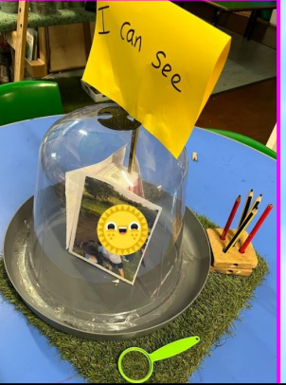
Helicopter Stories |  |  | Adults scribing and writing down word for word, child decides part he/she would like to play and then on a simple stage to act out the story.  Adults are dictated to by the child, the adult says each word as it is written, pointing out gaps and punctuation. Re-reading and scanning and checking writing. Child begins to write the initial sound of a word and the adult continues to write the other parts of the story. Children progress onto writing simple words with the support of a sound mat. |  | More phonetically correct words are written by child along with common words, e.g. ‘the’ and known tricky words. Can use a phonic mat or work bank to support. Adult writes any unknown words.  Child takes the pen more and more, until eventually they are writing complete phrases. May still need a phonics mat to support.
Maths  (Mastering Number) | Subitising within 3  Focus on counting skills  Explore how all numbers are made of 1s. Focus on composition of 3 and 4  Subitise objects and sounds  Comparison of sets - ‘just by looking’  Use the language of comparison: more than and fewer than | Focus on counting skills  Focus on the ‘five-ness of  5’ using one hand and the  die pattern for 5  Comparison of sets - by  matching  Use the language of  comparison: more than,  fewer than, an equal  number  Explore the concept of  ‘whole’ and ‘part’  Focus on the composition  of 3, 4 and 5  Practise object counting  skills  Match numerals to  quantities within 10  Verbal counting beyond  20 | Subitise within 5 focusing on die patterns  Match numerals to quantities within 5  Counting – focus on ordinality and the ‘staircase’ pattern  See that each number is one more than the previous number  Focus on 5  Focus on 6 and 7 as ‘5 and a bit’  Compare sets and use language of comparison: more than, fewer than, an equal number to  Make unequal sets equal | Focus on the ‘staircase’ pattern and ordering numbers  Focus on ordering of numbers to 8  Use language of less than  Focus on 7  Doubles – explore how some numbers can be made with 2 equal parts  Sorting numbers according to attributes - odd and even numbers | Counting – larger sets and things that cannot be seen  Subitising – to 6, including in structured arrangements  Composition – ‘5 and a bit’  Composition - of 10  Comparison – linked to ordinality  Play track games | Subitise to 5  Introduce the rekenrek  Review and assess:  Automatic recall of bonds to 5  Composition of numbers to 10  Comparison  Number patterns  Counting
Maths  SSM | Repeating patterns  Positional Language  2d shape | 2d shape  Time: Night and Day  Time: Sequencing  Measure: Length & height | Full/empty  Time: Days of the week  Capacity | 3d shape | Balance scales  Make balance cakes | Patterns
Understanding the World | TNW  Seasonal changes – Autumn – Squirrels  Longitudinal study look at the trees in the Autumn  Chronology: Talk about members of their immediate family and the relationship to them.  Name and describe people who are familiar to them.  Journey stick – around our school  Computing: Awesome Autumn | TNW  Exploring Ice (trapped super heroes)  Enquiry: Find out about key historical events and why and how we celebrate today? Remembrance Day, Christmas Day. Ask questions, use different sources to find answers including books.  Computing:  Super Space | TNW  Seasonal changes – Winter - Longitudinal study look at the trees in the Winter  Experiment & Investigation – what happens when materials freeze (water, shaving foam, Vaseline, oil)?  Chronology: Use the language of time when talking about past/present events in their own lives and in the lives of others including people they have learnt about through books. Talk about and understand changes in their own lifetime, by creating a personal timeline. Sequence events e.g. teeth brushing  Visually represent their own day on a simple timeline (correspond with number 7 work, days of the week)  Create a class timeline of their year in Squirrels.  Computing: Winter Warmers | TNW  Seasonal changes – Spring - Longitudinal study look at the trees in the Spring  P&P  How have we changed since we were babies?  Chronology:  Understanding the past through stories – looking at objects from Nursery Rhymes.  Enquiry: Describe images of familiar situations in the past using books such as, ‘When we were giants’, ‘Peepo’, Shirley Hughes stories.  Comment on images of familiar situations in the past. Describe features of objects, people, places at different times and make comparisons. Talk about what is the same and different.  TNW  Exploring and observing the natural world (tadpoles)  Explore floating and sinking – make a boat for the Gingerbread Man  Computing: Busy Bodies | TNW  Exploring and observing the natural world (tadpoles, & hatching eggs)  Animated frog life cycle  Frog life cycle  TNW  Similarities and differences between the natural world around them and contrasting environments  Chronology: Recount an event, orally, pictorial and/or with captions.  Computing: Springtime | TNW  Seasonal changes – Summer - Longitudinal study look at the trees in the Summer  PCC  Similarities and differences between life in this country and life in other countries  TNW  Similarities and differences between the natural world around them and contrasting environments  Enquiry: Recognise, know, and describe features of different places: Fair Trade mini project ‘b is for banana’ including walk to Sainsburys.  Look closely at similarities and differences between their immediate environment and different places they have visited, learnt about through books or websites.  Enquiry:  Exploring maps  Draw information from a simple map and identify landmarks of our local area walk. – Use Google Maps to show our Walk to Sainsburys.  P&P  Talk about the lives of people around us – their roles in society  Enquiry: Talk about key roles people have in society both in the present and past. Name and describe people who are familiar to them within their community e.g., police, fire service, doctors, dentist.  Computing: Summer fun
RE  Christianity and Judaism |  | Jesus’ birth  PCC  Know some similarities and differences between different religious  and cultural communities in this country | Celebration  Lunar New Year  PCC  Know some similarities and differences between different religious  and cultural communities in this country | New life at Easter  https://www.bbc.co.uk/cbeebies/watch/lets-celebrate-easter  Make an Easter Garden  PCC  Know some similarities and differences between different religious  and cultural communities in this country | PCC  Know some similarities and differences between different religious  and cultural communities in this country  What is a Celebration? How do we celebrate?  Celebrate Elmer’s Day.  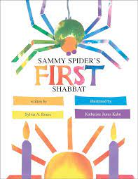  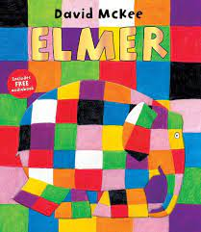  Shabbat | 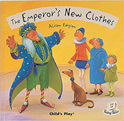  Special clothes  PCC  Know some similarities and differences between different religious  and cultural communities in this country
Expressive Arts & Design | CwM  Transient art self portraits  Access Art: Explorers books: Collecting colour  https://www.accessart.org.uk/explorers-books-collecting-colour/  Painting  Colour Mixing –autumn colours  Kandinsky – circle & triangle pictures (linked to Maths) | CwM  Firework art:  Transient art  Salad spinner art  Collage  Leaf man pictures  Access Art: Collaging with Wax Crayon Rubbings https://www.accessart.org.uk/collaging-with-wax-crayon-rubbings/  Access Art: Make an Autumn floor covering Autumn Floor Textiles https://www.accessart.org.uk/autumn-floor-textiles/  Poppies  Christmas cards  Calendars  BI&E  Nativity | CwM  Matisse inspired collage  Henri Matisse Painting with Scissors  Collage: Clothes for Jack Frost  Chalk winter pictures inspired by famous winter art  Transient art snowflakes  Access Art: Fruit & Veg heads  https://www.accessart.org.uk/fruit-and-veg-head/  BI&E  Roleplay:  Elsa’s castle  Vets  Lunar New Year Lion dance | CwM  printing with 3d shapes (links to Maths)  Observational drawing and painting: Daffodils & spring flowers  Access Art: Insect hotels  https://www.accessart.org.uk/insect-hotels/  Make a sock Bog Baby  BI&E  House role play with baby dolls | CwM  Observational drawing and painting: Tadpoles & ducklings  Access Art: Prop making for toys  https://www.accessart.org.uk/prop-making-for-toys/  Painting  Make an Elmer’s Day outfit for the parade  Drawing and Colour: Duckling inspired art looking illustrators Russell Ayto and Rob Biddulph  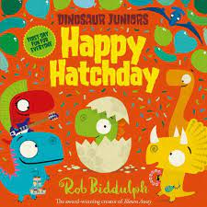  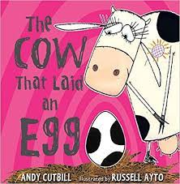  BI&E  Jungle roleplay | CwM  Access Art: Collage streets  https://www.accessart.org.uk/collage-streets/  Access Art: Cardboard creations  https://www.accessart.org.uk/top-tips-for-cardboard-creations/  Revisit Matisse – collaborative art inspired by ‘The Snail’  Symmetrical printing with paint (links to Maths)
Charanga | Me!  Pat-a-cake  1, 2, 3, 4, 5, Once I Caught a Fish Alive  This Old Man  Five Little Ducks  Name Song  Things for Fingers | My Stories  I’m A Little Teapot  The Grand Old Duke of York  Ring O’ Roses  Hickory Dickory Dock  Not Too Difficult  The ABC Song | Everyone  Wind the Bobbin Up  Rock-a-bye Baby  Five Little Monkeys Jumping on The Bed  Twinkle, Twinkle  If You're Happy and You Know It  Head, Shoulders, Knees and Toes | Our World  Old Macdonald  Incy Wincy Spider  Baa, Baa Black Sheep  Row, Row, Row Your Boat  The Wheels on The Bus  The Hokey Cokey | Big Bear Funk  Big Bear Funk  Hickory, Dickory  The ABC Song  Twinkle, Twinkle  Head, Shoulders, Knees and Toes If You're Happy and You Know It  Five Little Monkeys  The Wheels on The Bus  Baa, Baa Black  The Hokey Cokey  Row, Row, Row Your Boat | Reflect, Rewind & Replay:  Big Bear Funk  Baa, Baa Black Sheep  Twinkle, Twinkle  Incy Wincy Spider  Rock-a-bye Baby  Row, Row, Row Your Boat
Physical development | Dough Disco  Squiggle while you wiggle  Gymnastics - Body awareness  Children are body aware.  Show good control and body co-ordination. | Dough Disco  Squiggle me into a writer  Gymnastics - Body awareness  Children have a spatial awareness  Basic Shapes  Can show how the body can make different shapes. | Dough Disco  Squiggle me into a writer  Gymnastics - Apparatus  Explore the apparatus. Learn to safely use the apparatus. Perform a variety of jumps landing safely. | Dough Disco  Squiggle me into a writer  Dance  Children can move and react to the music.  Basic ball skills  Can show control of a ball. Can send a ball into a space and towards a target. | Dough Disco  Squiggle me into a writer  Athletics  To know the importance of good health and exercise.  Become familiar with Sports Day activities and equipment. | Squiggle me into a writer  Team Games  Child can show an awareness of space, adjusting speed and direction.
PSED/RR | Pantosaurus  Understanding Private parts and boundaries  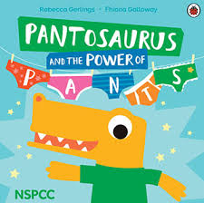  ‘No Outsiders Here’  You choose- Nick Sharratt & Pippa Goodheart – ‘We all like different things’  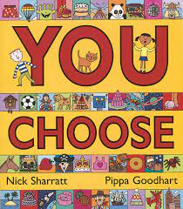  Red rockets and rainbow jelly- Sue Heap and Nick Sharratt - We like different things, we are friends  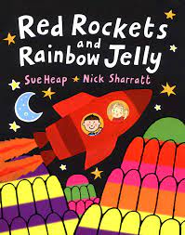 | My Happy Mind: Meet Your Brain  Know and talk about the different factors that support their overall health and wellbeing:  • regular physical activity  • healthy eating  Developing Experts: Food: Learn about Your Diet and How to Stay Healthy  Make a Healthy Fruit Smoothie | My Happy Mind: Celebrate  RR: What is a right  Wants vs Needs  Class Charter:  19 We have the right to be safe  28 the right to learn  31 The right to play | My Happy Mind: Appreciate | My Happy Mind: Relate | My Happy Mind: Engage  Oral hygiene and Healthy eating  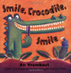
Forest School | Autumn  Introduction to Forest School  Fire Safety  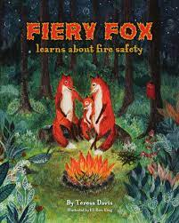 | How to put out a fire safely | Winter  Cooking on a campfire  Bird feeders  Hibernation | Spring  Explore how to care for the wild animals that live in our local area.  Use logs and sticks to make a habitat pile to attract mini beasts: http://www.rspb.org.uk/advice/gardening/deadwood.aspx  Build an insect home: http://www.rspb.org.uk/advice/gardening/insects/building_homes.aspx  Make a home for the Bog babies  Water colour painting  Making seed bombs | Introduce tools  Bow Saws  Potato peeler  Hapa Zoma  Dandelions  Making a nest for an orangatan  Pond Dipping | Summer  Elder Tree  Using Tools  Map of Forest School  Using a flint & steel

