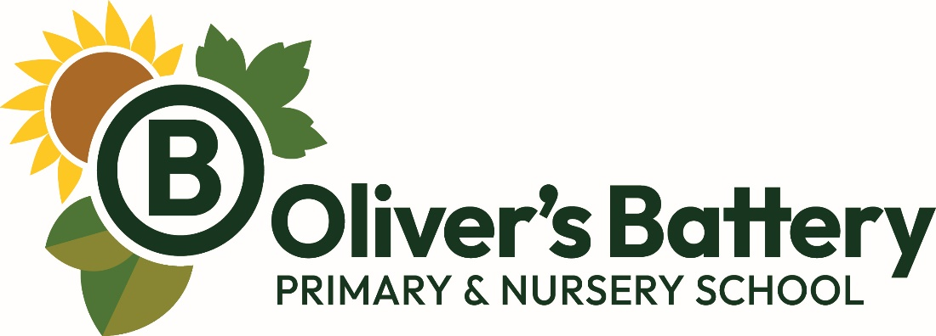

Wrap Around Care Policy

Version | 1
Date of latest version | October 2026
Date to be reviewed | July 2027
Changes:
New Policy

Introduction

A Wraparound Childcare service (Early Morning Club and After School Club) is provided at Oliver’s Battery Primary and Nursery School. Childcare Holiday Clubs may also be run on site during school holidays when staff are available and when demand for places is sufficient.

Early Morning Club

Early Morning Club runs from 7.50am - 8.45am Monday to Friday during school term times. The cost is:
£3 per session (£4 if booked less than 48 hours in advance).
Children from Year R to Year 6 may attend. Breakfast is not provided but children may bring in their own food and drinks.

After School Club

After School Club runs from 3.30pm – 6pm Monday to Friday during school term times. The costs are:
£9.50 for 3.30-5pm
£15.00 for 3.30-6pm
£9.50 for 4.30-6pm
£9.50 for 1.5 hours around a provider run club
£5.00 for 4.30-5pm after a provider run club
Children from Year R to Year 6 may attend. Healthy snacks are provided and these are included in the prices listed above.

Payments
• Sessions can be booked via the ScoPay App. Your ScoPay account must be in a positive balance to book. Debt may not be built up against After School Club and Early Morning Club bookings.
• All sessions will need to be paid for in advance and in full at the time of booking with the exception of Childcare Voucher and Government Tax Free Childcare scheme payments as these are administered by the school office.
• Payment can be made via the Government Tax Free Childcare Scheme (subject to eligibility criteria). In order to use this method of payment, you will need to register with HMRC and set up a personal account. HMRC will then process your payment and pay the school directly.
• Payment can also be made using Childcare Vouchers through your employer. Please contact the school office for further information about this.

Terms and Conditions
1. Early Morning Club and After School Club runs during term time only and are closed during holidays and “INSET” (training) days. Early Morning Club does not run on the last day of the Autumn Term. We reserve the right to not run Early Morning Club and After School on other date(s) should circumstances arise. We will contact parents as soon as possible about any cancellations.
2. All spaces are subject to availability and will be allocated on a first come first served basis. Please note that spaces are limited.
3. In cases of genuine illness, a refund of Early Morning Club and After School Club session can be requested. Please contact the school office for this to be processed. We can also transfer your ScoPay credit to another session.
5. If a 3.30-5pm After School Club session is booked and you collect your child more than 10 minutes late without prior notice, we reserve the right to charge for a 3.30-6pm After School Club session
6. If you arrive after 6pm to collect your child after a 3.30-6pm After School Club session, we reserve the right to charge a £5 late collection fee for every 15 minutes late collection
7. There will be no refund/discount for early collection or late drop off of your child from our Early Morning Club and After School Club.
8. Early Morning Club and After School Club fees will be reviewed annually. Price rises will be communicated as soon as possible
9. Places at our Early Morning Club and After School Club need to be booked online via the ScoPay App at least 48 hours in advance. This is so accurate registers can be created and attendance data can be shared with staff to ensure all Safeguarding requirements are met.
We recognise that emergencies can occur and should space be available, bookings after the 48 hour deadline can be made via the school office or via email (admin@oliversb.com). A higher price of £2.00 extra per session will apply.
12. Staff reserve the right to exclude children from the club if their behaviour is considered unsafe. Parents will be informed if a problem has arisen.
13. We reserve the right to withdraw any booking made if a parent or a pupil is repeatedly not adhering to the school values, rules and policies.
14. No child is to attend Early Morning Club and After School Club without a prior booking being made.
15. Nursery children are not routinely able to attend Early Morning Club and After School Club. If you feel special circumstances apply, please contact our Headteacher, Miss Sarah Vittle, via the school office (admin@oliversb.com) to discuss this.

Holiday Clubs
The school may run holiday clubs during the school holidays.

Summer Holiday Club
Summer Holiday Club will be run on selected dates during the Summer School Holidays. These will be communicated with parents.
Summer Holiday Club will run from 9am – 5pm. The charge is:
£28 per day
Children in our current Year R to our current Year 6 may attend. Lunch is not provided.

Payments
• Sessions can be booked via the school office by emailing admin@oliversb.com. Once a place is confirmed, it will be added to your ScoPay account.
• All sessions will need to be paid for in advance and in full at the time of booking. Our preferred method of payment is online via the ScoPay app. We also accept cash at the school office. Debt may not be built up against Holiday Club bookings.

Terms and Conditions
1. Holiday Club runs during selected school holiday periods.
2. All spaces are subject to availability and will be allocated on a first come first served basis. Please note that spaces are limited.
3. In cases of genuine illness, a refund of a Holiday Club session can be requested. Please contact the school office for this to be processed. We can also transfer your ScoPay credit to another session. Please note that the school office is closed during school holidays and there will be a delay in processing your refund and actioning your request.
4. If you arrive after 5pm to collect your child after Holiday Club session, we reserve the right to charge a £5 late collection fee for every 15 minutes late collection
5. There will be no refund/discount for early collection or late drop off of your child from our Holiday Club.
6. Holiday Club fees will be reviewed annually. Raises will be communicated as soon as possible
7. Staff reserve the right to exclude children from the club if their behaviour is considered unsafe. Parents will be informed if a problem has arisen.
8. We reserve the right to withdraw any booking made if a parent or a pupil is repeatedly not adhering to the school values, rules and policies.
9. No child is to attend Holiday Club without a prior booking being made.
10. If in cases of emergency, staff illness or other circumstances beyond our control we have to cancel a day of Holiday Club, we will contact you as soon as possible to let you know. A full refund will be given (when the school office is next open).
15. Nursery children are not routinely able to attend Holiday Club. If you feel special circumstances apply, please contact our Headteacher, Miss Sarah Vittle, via the school office (admin@oliversb.com) to discuss this.

